AIAMC INNOVATION AWARD

The AIAMC presents the Innovation Award on an annual basis to its institutional member who best exemplifies creative and innovative approaches to medical education and research. The institution selected for this prestigious honor must demonstrate an innovation in the following categories:

- The development and/or implementation of innovative medical education programs for residents, physicians and other staff and may include curriculum development and implementation, assessment methodologies, and/or outcomes related to medical education initiatives.
- Innovation significant themes such as provider well-being, quality improvement, population health, health disparities and/or cultural competency initiatives involving residents, physicians and other staff and related outcomes.
- The development and/or application of scientific discoveries. Areas of research may include education, health care improvement, biomedical research and/or translational research.

Prior winners may be viewed here: https://aiamc.org/awards

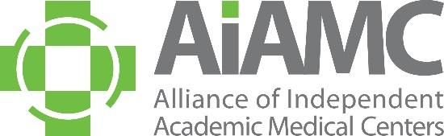

ALLIANCE OF INDEPENDENT
ACADEMIC MEDICAL CENTERS
Innovation Award Application Form

Institution Name:

City, State:

Web Site:

Institution Contact:

Title:

Phone: Email:

1. Describe how the nominee has developed and/or implemented innovative approaches to medical education and/or research by completing the following Innovation Abstract. Please limit to 500 words):

a. Title

b. Contributors/Authors

c. Introduction/Background

d. Significance

e. Methodology/Innovation Development and Evaluation

f. Outcomes/Impact

g. Discussion/Conclusions

Innovation Award Application Form
Page 2 of 2

2. Has the nominee received national recognition for this specific project/submission?

□ Yes □ No

If yes, please describe:

3. Please describe how this work might be scale-able and disseminated to other AIAMC members and
the GME learning community.

4. If chosen for this award, will the nominee be present at the AIAMC 2026 Annual Meeting to be held
April 16th – 18th at the Omni La Costa Resort and Spa in Carlsbad, California? The award will be presented at the April 17th Awards Dinner. (Please note the institution should ideally be represented by its CEO & CAO)

□ Yes □ No □ Not Sure

Please send this completed form to
Kimberly Pierce Burke, Executive Director,
by e-mailing Kimberly@aiamc.org
NO LATER THAN NOVEMBER 15, 2025

